HEALTHY EATING
If one wants to stay healthy, one needs to eat a healthy diet and supplement it with a good dose of exercise. But, many people question, “What should I eat to keep healthy?” or “What constitutes a healthy diet?”
The answer lies in eating a balanced diet, one containing a combination of different foods which provide the body with all the essential nutrients in the correct amounts. The important nutrients are: carbohydrates, proteins, fats (lipids), vitamins, minerals, water and fibre. These nutrients are all required by the human body and a lack of any of them leads to malnutrition, possibly with serious consequences.
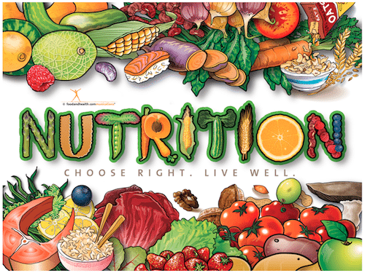

Image reproduced from https://foodandhealth.com/make-a-nutrition-poster/
CARBOHYDRATES AND FIBRE
Carbohydrates are the most important source of energy in the human body. So, the more active a person is, the more of these he/she requires. In the digestive system, carbohydrates are broken down to a sugar called glucose, which is then used by the body to provide energy for cells, tissues and organs. Extra sugar can be stored in muscles and liver until needed. Starchy foods contain fewer than half the calories of fats per gram.
Carbohydrates may be simple or complex.
- Simple carbohydrates are sugars such as those found naturally in fruits, milk etc. as well as those sugars added during food processing and refining.
- Complex carbohydrates, such as starch, consist of sugar molecules strung together to form long complex chains. They are found in foods such as cereals, bread, rice, legumes and starchy vegetables like potatoes. Complex carbohydrates derived from whole grain foods are also good sources of fibre, which is essential for health since it reduces constipation and decreases the risk of certain cancers like colon cancer. Moreover, complex carbohydrates are often associated with vitamins and minerals.
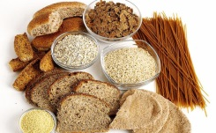
So, most of the carbohydrates we eat should be derived from complex carbohydrates and naturally-occurring sugars, rather than refined or processed sugars which provide very little nutritional value and are rightly often called “empty calories”. Most starchy foods have a high-fibre version. So, one should replace white rice, pasta and bread with brown rice, wholemeal pasta and whole grain bread. Baked jacket potatoes (with the skin) and wholegrain breakfast cereals also are rich in both fibre and energy.
EAT: |  | AVOID:
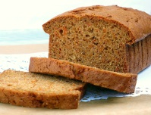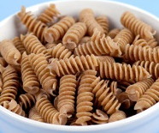 |  | 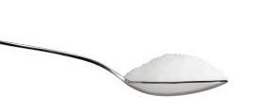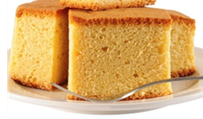
PROTEIN
Every single cell in the human body contains proteins. In fact, proteins are considered to be the building blocks of life. They are needed to build and maintain bones, muscles and skin. They are used to make new cells for growth and to repair damaged ones. They are particularly needed by children, adolescents and pregnant women.
Proteins are derived from two main sources:
- Animal sources such as meat, fish, eggs, milk and other dairy products; these are considered to be sources of complete protein because they provide all the amino acids that the human body cannot make.
- Plant sources such as beans, peas, nuts, soy, lentils and quinoa; with the exception of quinoa, these are said to be incomplete protein sources because individually they don’t supply all the essential amino acids. However, it is possible to get all the amino acids the body needs if one combines different types of plant proteins.
The human body is unable to store protein. As a result, it is important to eat some protein every day. The average person should eat 50 to 65 grams of protein daily.

EAT:
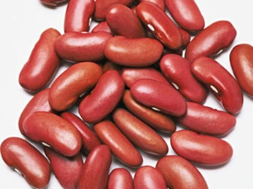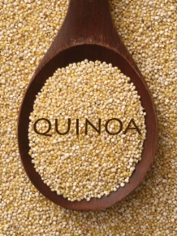
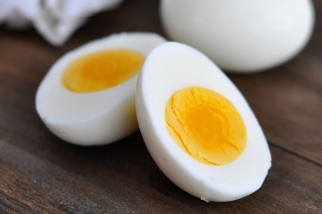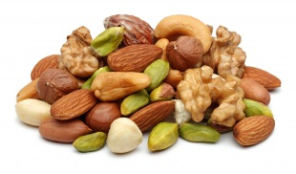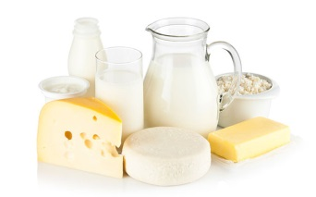

FATS
Fats are needed in our diet in small amounts. They provide energy and dissolve fat-soluble vitamins (A, D, E, K). However, excess fat intake leads to weight gain, as fat provides more than double the calories from carbohydrates and protein. Being overweight has been linked to poor health.
There are several types of dietary fat:
- Saturated fat: This comes from animal sources like red meat and full-fat dairy products. It raises blood cholesterol levels, increasing the risk of cardiovascular disease and diabetes.
- Trans fat: This is found mostly in margarines, crackers, biscuits and snacks that are made with or fried in partially hydrogenated oils. It tends to raise unhealthy cholesterol levels and increase the risk of cardiovascular disease.
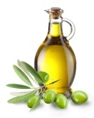
- Monounsaturated and polyunsaturated fatty acids: These are found in a variety of plant-based foods and oils including olive oil, safflower oil, peanut oil and corn oil. They improve blood cholesterol levels and may decrease the risk of heart disease and diabetes.
- Omega-3 fatty acids: These are a type of polyunsaturated fat found in fatty fish such as salmon, fresh tuna, mackerel, sardines, trout and herring and in some plant-derived sources like walnuts, canola oil and flaxseed. It is beneficial to health and reduces the risk of heart problems.
So, foods rich in saturated and trans fats supply potentially harmful dietary fat and should be avoided. On the other hand, foods rich in monounsaturated and polyunsaturated fatty acids (including omega-3 fatty acids) supply potentially helpful fats and should be consumed in moderation.
EAT: |  | AVOID
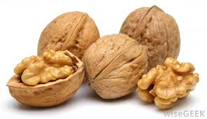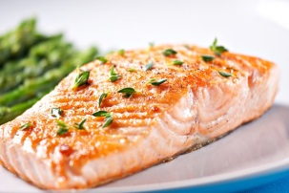
MINERALS
Minerals are needed in small amounts to grow and stay healthy. They include calcium, iron, phosphorus, magnesium iodine, copper, zinc and many others. Minerals are required for various jobs in the human body. The table below summarizes the basic function of some important minerals and gives examples of foods that are rich in them.
Calcium | For strong bones and teeth and for muscle contraction | Milk, dairy products such as yoghurt & cheese, broccoli
Iron | For red blood cells to carry oxygen | 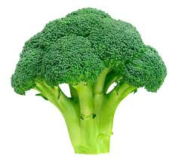  Red meat, spinach, beans, broccoli, raisins and soy foods. Many cereals are fortified with iron.
Phosphorus | For strong bones and teeth, for cells to make energy and in cell membranes | Dairy products like cheese, meat and fish
Magnesium | Helps muscles and nerves work properly, steadies the heart rhythm and helps the body make proteins and create energy | 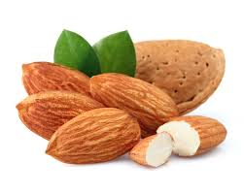  Whole-grain products, nuts and seeds, milk, green leafy vegetables, milk, potatoes, beans, avocados, bananas,
Potassium | Helps the heart muscle and nerves to function well, and the body to maintain the right water balance | Bananas, peas, broccoli, potato skin, green leafy vegetables, citrus fruits, dried fruits
Zinc | For normal growth, proper wound healing and good immunity | 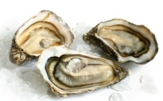  Seafood, nuts, red meat, poultry, milk and other dairy products, whole grains, fortified breakfast cereals.

VITAMINS
Vitamins are a group of substances which the human body needs to grow and develop normally. The table below gives some examples of foods rich in the vitamins our body needs and outlines their function in the body.
Vitamin | Function | Sources
Vitamin A | Important for vision and for immunity | 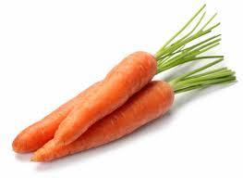  Carrots, liver, whole milk
B Vitamins (a group of vitamins including B1, B2, B3, B5, B6, B7, B12) | Important for proper metabolism in the body, including getting energy from carbohydrates and fats | Various foods supply different B vitamins; many fortified cereals contain a variety of B vitamins; a balanced diet supplies all the B vitamins
Folic acid | Important to make healthy new cells; important during pregnancy to prevent spinal defects in the baby | 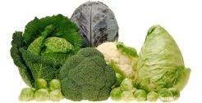  Leafy green vegetables, dried beans and nuts, fortified cereals
Vitamin C | Important for healthy skin, bones and connective tissue and helps the body absorb iron | Citrus fruits, strawberries, red and green peppers, broccoli, tomatoes
Vitamin D | Important for absorption of calcium | Liver, milk, egg yolks, oily fish  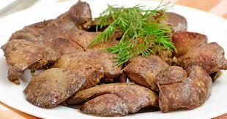  also made in the skin when exposed to sunlight
Vitamin E | Important for the immune system to work well | Vegetable oils, margarine, nuts and seeds
Vitamin K | Needed to make proteins for blood clotting and healthy bones | Spinach, lettuce, cabbage, dark berries, prunes

How much should you eat?
It is not just the type of food that one must be careful about but also the amount of each food type that is eaten. A useful indicator of the quantity of various foods that should be eaten is a food pyramid, which depicts the various foods as being split into five food groups:
- Grains – rich in carbohydrate and fibre
- Fruit and vegetables – rich in vitamins, minerals and fibre
- Milk and dairy products – rich sources of protein and calcium
- Meat, fish, poultry and alternatives – high in protein and minerals
- Foods that are rich in sugar and/or fat and/or salt
WHO Europe has developed the CINDI pyramid (CINDI = Countrywide Integrated Non communicable Disease Intervention programme), depicted in Figure 1. This pyramid uses the colours of traffic lights to indicate the degree to which the various food types should be consumed for a healthy balanced diet.
- The green colour is found at the base of the pyramid for grains, fruits and vegetables. The green colour signifies “Go ahead”. So, these foods should constitute the largest part of the diet.
- Milk/dairy products and meat/fish/eggs/alternatives are in the orange, middle part of the pyramid. The orange colour indicates that only moderate amounts of these foods are recommended for a healthy, balanced diet.
- Red is found at the top of the pyramid, covering fat, oils and sugars. The red colour informs people that only very small amounts of these foods are needed.
The CINDI food pyramid also reminds us that regular exercise goes hand in hand with a balanced diet for a healthy lifestyle.
Figure 2 depicts the Irish food pyramid that indicates the daily number of recommended servings for the different food types.
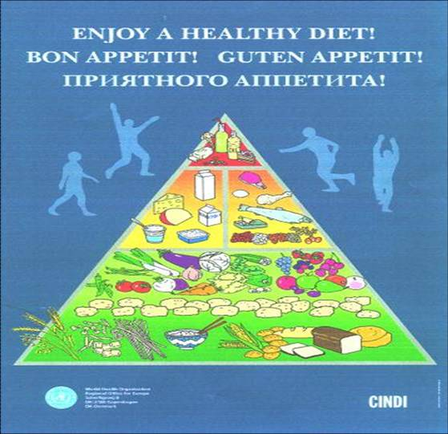
Figure 1: CINDI food pyramid
(Reproduced from http://www.eufic.org/article/en/expid/food-based-dietary-guidelines-in-europe/)

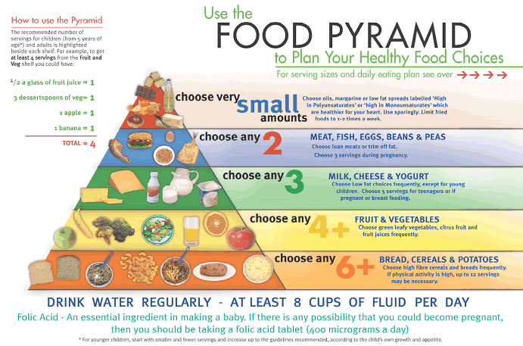
Figure 2: The Irish food pyramid
(Reproduced from http://www.eufic.org/article/en/expid/food-based-dietary-guidelines-in-europe/)
The table below gives the number of servings for each food group for the average adult and children over the age of 5 years and also provides an indication of what a serving is.
Food group | Number of servings | What constitutes a serving?
Grains  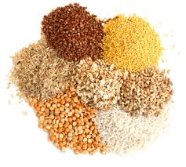 | 6  (more for very active persons) | - 1 slice wholemeal bread  - 2-3 crackers  - ½ tortilla wrap  - 4 dessert spoons high-fibre cereal without honey, sugar or chocolate)  - 1 medium potato  - 25 grams uncooked pasta or rice  - ½ bread roll
Fruit and vegetables  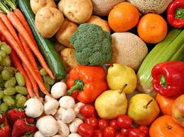 | At least 4 | - 1 medium apple, orange, banana, pear or similar size fruit  - 2 small fruits such as plums  - 10-12 berries or grapes  - 1 heaped dessertspoon of raisins  - 3-4 dessertspoons of cooked vegetables  - a bowl of salad – lettuce, tomato, cucumber  - a bowl of homemade vegetable soup  - a small glass (100ml) of unsweetened fruit juice or a smoothie made only from fruit or vegetables
Milk and dairy products  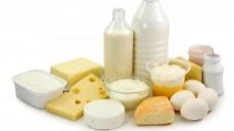 | 3  (5 for teens, pregnant and breast-feeding women) | - 1 large glass (200ml) low fat milk  - 1 small carton yogurt (125ml)  - 1 yogurt drink (200ml)  - 25g low fat cheddar or semi-soft cheese  - 50g low fat soft cheese  - 75g cottage cheese
Meat, fish, poultry, nuts, eggs and beans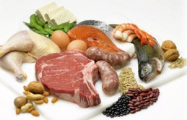 | 2  (3 during pregnancy) | - 50-75g cooked lean beef, pork, lamb, lean mince, chicken  - 100g cooked fish  - 2 eggs (limit to 7 eggs a week)  - 100g soya or tofu  - 6 dessertspoons of peas, beans or lentils  - 40g unsalted nuts or seeds
TIPS FOR A HEALTHY DIET
- Eat a variety of foods to ensure a balanced diet containing all the important nutrients.
- Include plenty of foods that are rich in carbohydrates – eat them in amounts compatible with your activity level.
- Choose whole grains over refined grains as they contain more fibre, vitamins and minerals. Select wholegrain bread, rice and pasta over the white varieties.
- Minimize the amount of sugar you add to your food. If you are in the habit of adding a lot of sugar, decrease the amount gradually, to give time for your taste buds to adjust to a less sweet taste.
- Choose fortified wholemeal breakfast cereals that don’t have sugar, honey or chocolate coatings.
- Don’t skip breakfast. Eating a healthy breakfast helps jumpstart your metabolism.
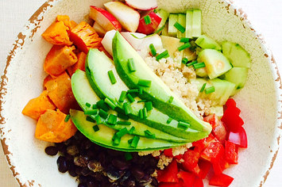
- Eat plenty of fresh, local fruit and vegetables in season.
- Include a variety of coloured fruit and vegetables – green, yellow, orange, red and purple - in order to benefit from the diverse vitamins and minerals provided by each colour group.
- Grate vegetables like carrots or marrows into bolognaise or add lots of vegetables to homemade tomato sauce and blend, especially for children who are not too keen on veg.
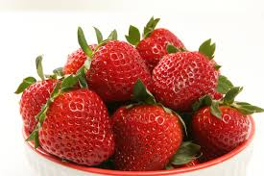
- Cut down on sweet or savoury snacks such as chocolate, sweets, crisps and cakes Too much sugar, especially between meals increases the risk of tooth decay, besides adding extra calories
- Replace sugary snacks with fruit, Greek yoghurt, nuts and seeds..
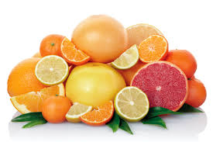
- Eat vitamin C rich fruit (e.g. orange, tangerine, strawberries) daily.
- Remember that, while freshly squeezed fruit juice provides plenty of vitamins, it is low in fibre. So, it is better to eat the whole fruit than to just drink its juice.
- Avoid drinking packaged fruit juices that have added sugar as these provide empty calories and encourage tooth decay.
- Avoid soft drinks which are also loaded with sugar.
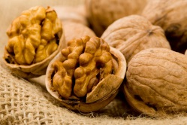
- Replace unhealthy saturated fats from butter, lard, pastries, cream, pies and cheese with unsaturated fats found in vegetable oils, nuts, seeds, oily fish and avocados.
- Eat small amounts of omega-3-rich foods, like fish, walnuts and olive oil regularly.
- Choose lean meat, trim excess fat from meat and remove skin from poultry.
- Restrict consumption of processed meats such as bacon, sausages or ham, as these tend to be high in fat and salt.
- Choose low-fat or skimmed milk options (except for children under the age of 5 years).
- When eating cheese, try to choose a lower fat cheese rather than a full-fat cheese.
- Consume more skimmed milk and yoghurt and less cheese.
- Use low-fat yoghurt instead of cream where possible.
- Try to eat fish twice a week, of which oily fish at least once a week. Remember oily fish supply both omega-3 fatty acids and Vitamin D,
- Smoked fish contain salt and canned variety may also do so, so check food labels and choose low-salt varieties.
- Inclusion of an iron-rich food such as red meat, spinach or egg yolks is important for children, teenagers and women. Having a vitamin C food/drink in the same meal with the iron-rich food increases the amount of iron absorbed.
- Eat beans and peas as these are a good source of protein and are low in fat.
- Drink plenty of water. Dehydration can lead to tiredness, lethargy and headaches.
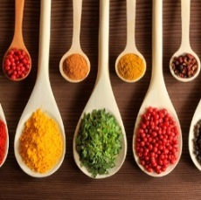
- Prepare more of your own meals – that way you know what’s inside them.
- When cooking, use herbs and spices such as rosemary, mint, garlic, pepper and curry to improve the flavour of meals rather than salt.
- Read the food labels of packaged food items carefully to check for hidden sugars or unhealthy fats. Packaged foods like canned soups or frozen dinners are usually high in sugar and salt.
- Eat slowly and stop eating before you feel very full.
- When eating out, ask for dressings and sauces to be served at the side or in reduced amount.
- Control your portion size. It may help to use a smaller plate.
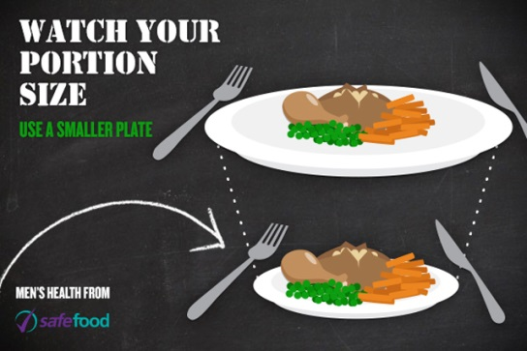
Image reproduced from http://www.safefood.eu/Healthy-Eating/Food,-Diet-and-Health/Seasonal-Features/Men-s-Health-Week/Watch-your-portion-sizes.aspx

DO NOT OVEREAT!
Eating moderate portions of healthy food on a regular basis and drinking plenty of water, accompanied by physical activity, should help you maintain a good body weight and stay healthy.

Web sites:

http://www.eufic.org/article/en/expid/10-tips-healthy-eating/

http://www.helpguide.org/articles/healthy-eating/healthy-eating.htm

https://www.nlm.nih.gov/medlineplus/ency/article/002467.htm

http://www.eufic.org/article/en/expid/food-based-dietary-guidelines-in-europe/

https://www.nlm.nih.gov/medlineplus/

http://www.safefood.eu/Healthy-Eating/The-Food-Pyramid-and-The-Eatwell-Plate.aspx

http://www.mayoclinic.org/healthy-lifestyle/nutrition-and-healthy-eating/in-depth/fat/art-20045550

http://kidshealth.org/teen/misc/mineral_chart.html

http://www.safefood.eu/Healthy-Eating/Food,-Diet-and-Health/Seasonal-Features/Men-s-Health-Week/Watch-your-portion-sizes.aspx

