SENIOR 2 WER SCIENCE ACTIVITY

On Friday 22nd April, the Senior two students participated in an activity related to the We Eat Responsibly! project which our school is actively involved in. The activity took place during a science lesson and was led by science teachers, two of which are also Eko-skola members.
The objectives of this activity were:
- to find out what information about goods are taken into consideration by pupils when selecting and purchasing produce
- to assess their level of awareness regarding issues related to the environmental benefits of consumption of local and seasonal fruit and vegetables
- to encourage the girls to eat more fruit and vegetables by emphasizing their nutritional value
- to get students to form an opinion about a real life situation and express arguments supporting this
- to promote an increased interest in sustainable development and responsible eating.
In the first activity, “Not every tomato is the same”, the students were presented with five options of tomato products having different packaging, different countries of origin and different vendor types.
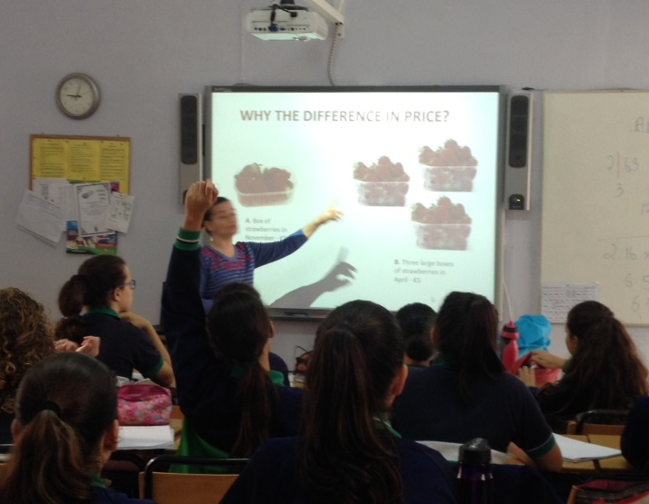

The pupils were asked to select which they thought was the best option of product from a consumer point of view and explain their choice to the class. Whilst some students demonstrated an awareness of environmental issues related to pollution caused by the use of pesticides, transportation and packaging, others focussed more on personal issues like price and visual appearance.
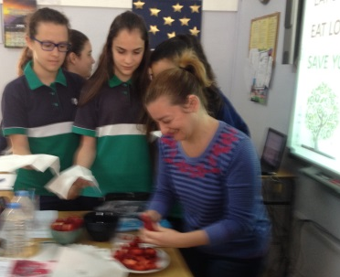
In the second activity, students were asked to give reasons for the vast difference in price of strawberries in November and in April. The majority of students were aware of the reduction in price associated with seasonality and several were able to give satisfactory reasons for this, few made a link between the price increase and environmental issues.

At the end of the activity, the girls were treated to a strawberry snack which they thoroughly enjoyed!

